**Real-TimeResearchProject Report**

**On**

**SPAMDETECTIONUSINGPYTHON TECHNIQUES**

Submittedto

# JAWAHARLALNEHRUTECHNOLOGICALUNIVERSITY

in partial fulfillment of the requirement for the award of the degree of

# BACHELOROFTECHNOLOGY IN

**COMPUTERSCIENCEANDENGINEERING(AI&ML)**



**SUBMITTEDBY:**

**A.POOJITHA (HTNO:22TR1A6601)**

**A.ASHISH (HTNO:22TR1A6602)**

**A.NIMISHA (HTNO:22TR1A6603) A.PURNACHANDER (HTNO:22TR1A6604) B.MOUNIKA (HTNO:22TR1A6605)**

**CH.BHARATH (HTNO:22TR1A6606) CH.SAI KUMAR (HTNO:22TR1A6607) CH.JYOTHI (HTNO:22TR1A6608) CH.UDAY THARANG(HTNO:22TR1A6609) CH.VISHNU VARDHAN (HTNO:22TR1A6610)**

**DEPARTMENTOF**

**COMPUTERSCIENCEANDENGINEERING(AI&ML)**

**SREECHAITANYAINSTITUTEOFTECHNOLOGICALSCIENCES**

**LMDCOLONY,KARIMNAGAR-505527**

**(ApprovedbyAICTE,AffiliatedtoJNTUH,Hyderabad)**

**SREECHAITANYAINSTITUTEOFTECHNOLOGICALSCIENCES**

**LMDCOLONY,KARIMNAGAR-505527**

**(ApprovedbyAICTE,AffiliatedtoJNTUH)**

Certificate



Certified that thisReal-Time Research Project Reportentitled,**“Spam Detection Using Python Techniques”**is the bonafide work of**A.Poojitha (H.T.No.22TR1A6601),A.Ashish(H.T.No.22TR1A6602),A.Nimisha**

**(H.T.No.22TR1A6603), A.Purnachander(H.T.No.22TR1A6604),B.Mounika (H.T.No.22TR1A6605),CH.Bharath(H.T.No.22TR1A6606),CH.Saikumar(H**

**.T.No.22TR1A6607),CH.Jyothi(H.T.No.22TR1A6608),CH.UdayTharang(H**

**.T.No.22TR1A6609)**and**CH.VishnuVardhan(H.T.No.22TR1A6610)ofII Year, CSE (AI&ML)**in the academic year 2023-2024 in partial fulfillment of the requirements to award the Degree of Bachelor of Technology in **Computer Science and Engineering (AI&ML) Branch**ofSree Chaitanya Institute of Technological Sciences, Karimnagar.

**Mrs.R.HARITHA Dr.PEDDIKISHOR**

**Assistant Professor Associate Professor Coordinator Head of theDepartment**

# TABLEOFCONTENTS

Abstract IV

PageNosStart–End

Chapter1:INTRODUCTION 1-2

Chapter2:RESEARCHPROBLEM 3

Chapter3:RESEARCHOBJECTIVES 4

Chapter4:SYSTEMANALYSIS 5-6

Chapter5:SOFTWAREANDTOOLS 7

Chapter6:IMPLEMENTATION 8-10

Chapter7:CODING 11-12

Chapter8:OUTPUTRESULTS 13-15

Chapter9:CONCLUSION 16

REFERENCES 17-18

# ABSTRACT

Emailspamremainsapervasiveissue,inundatinguserswithunsolicitedmessages that can range from annoying promotions to malicious content. Addressing this challenge,ourprojectfocusesonimplementingmachinelearningtechniquesto classify emails as either spam or legitimate (ham). Leveraging the Naive Bayes and Support Vector Machine (SVM) algorithms, we explore their effectiveness in distinguishing between spam and ham based on textual features extracted from email content.

The project utilizes a dataset curated for email classification, encompassing diverse textual characteristics and labeled instances of spam and ham. Through the implementationprocess,weapplytheCRISP-DM(Cross-IndustryStandardProcess forDataMining)methodologytoguideourprojectlifecycle—fromdata understanding and preprocessing to model building, evaluation, and deployment.

Our findings underscore the robustness of Naive Bayes and SVM in accurately categorizing emails, with performance metrics such as precision, recall, and F1-score serving as benchmarks. The project aims not only to build effective classifiers but alsoto provide insights into the feature importance and model interpretability crucial forreal-world applications.

# CHAPTER 1 INTRODUCTION

Email communication has revolutionized global connectivity, serving as a cornerstoneof modern digital interaction. However, alongside its utility comes the persistent challenge of spam—unwanted, unsolicited emails that inundate inboxes with advertisements, phishing attempts, and potentially harmful content. The prevalence of spam not only disrupts personal and professional communications but also poses significant cybersecurity risks, including identity theft, financial fraud, and malware dissemination.

Traditionalspamfilteringtechniques,reliantonrule-basedsystemsandheuristic approaches,areincreasinglyinadequateincombattingsophisticatedspammingtactics. These methods often struggle to adapt to evolving spam strategies that employ obfuscation,socialengineering,andcontentmanipulationtoevadedetection.Asa result,thereisacriticalneedforadvanced,adaptivesolutionsthatcaneffectively discern between legitimate emails (ham) and spam with high accuracy and efficiency. Machinelearning,asubsetofartificialintelligence,offersapromisingavenuefor enhancingemailspamdetectioncapabilities.Byleveragingalgorithmscapableoflearningfromdata,machinelearningmodelscanautonomouslyidentifycomplexpatterns and anomalies indicativeofspam. Two prominentalgorithms in this domainareNaiveBayesandSupportVectorMachine(SVM),bothknownfortheirrobust performance in text classification tasks.

Naive Bayes operates on the principle of probabilistic reasoning, assuming independence between features while effectively handling large volumes of textualdata. In contrast, SVM excels in separating data points by finding the optimal hyperplanethatmaximizesthemarginbetweendifferentclasses,makingit particularly suitable for binary classification tasks like spam detection.

This project focuses on evaluating the effectiveness of Naive Bayes and SVM algorithmsinidentifyingspamemailswithinadiversedatasetsourcedfromreal- world email communications. Through rigorous experimentation and evaluation, weaim to assess how well these algorithms generalize to unseen data and their respective strengths and weaknesses in differentiating between spam and legitimate emails.

Theoutcomesofthisresearchareexpectedtocontributeinsightsintooptimizing spam detection strategies, improving email security frameworks, and enhancing user experienceinmanagingemailcommunications.Byadvancingthefield's understanding of cybersecurity challenges in email communication, this study aims to propose practical solutions that mitigate the impact of spam and bolster digitalresilience against evolving threats.

Through this study, we aim to evaluate how well Naive Bayes and SVM algorithms generalizetodiverseemaildatasets,drawnfromreal-worldemailcommunications. By conducting rigorousexperiments and performanceevaluations,we seek to assess the algorithms' capabilities in accurately distinguishing between spam and legitimate emails, considering factors such as feature selection, model training, and validation techniques.

Furthermore, this research contributes to enhancing understanding of email security challenges and advancing techniques for improving spam detection systems. By identifying strengths and limitations of Naive Bayes and SVM approaches, this study aims to provide insights that can inform the development of more effective email filtering mechanisms, thereby enhancing user confidence and mitigating risksassociated with malicious email activities.

Thefindingsfromthisresearchareexpectedtooffervaluablecontributionstothe field of cybersecurity, aiding in the development of robust email spam detectionsystems that can adapt to evolving threats and protect users frompotential harm.

# CHAPTER 2 RESEARCHPROBLEM

Email spam remains a persistent threat in the digital communication landscape, posing significant challenges to individuals, businesses, and organizations worldwide. The primary issue lies in effectively distinguishing between legitimate emails (ham) and unsolicited spam emails, which often contain malicious content or deceptive schemes aimed at deceiving recipients.

Traditionalrule-basedspamfilters,whileinitiallyeffective,struggletokeeppace withtheevolvingtacticsusedbyspammers.Modernspamemailsemploy sophisticatedtechniquessuch as social engineering,image-based spam,and obfuscation strategies to evade detection. As a result, there is a pressing need for more advanced and adaptive approaches to accurately classify emails and mitigate the risks associated with spam.

Machine learning algorithms offer a promising solution by leveraging computational methods to automatically learn and adapt from data.However, theeffectiveness of these algorithms, such as Naive Bayes and Support Vector Machine (SVM), in identifyingspamemailsvariesbasedonseveralfactors,includingthequalityof feature selection, model training techniques, and the diversity of datasets used for evaluation.

The research problem addressed in this study revolves around evaluating the performance and comparative effectiveness of Naive Bayes and SVM algorithms in detecting email spam. Specifically, the study aims to:

* Assess the accuracy, precision, recall, and F1-score of Naive Bayes and SVM classifiers in distinguishing between spam and ham emails.
* Investigatetheimpactoffeatureengineeringtechniques,suchastext preprocessing, feature selection, and vectorization methods, on algorithm performance.
* Evaluate the algorithms' ability to generalize across different email datasets, encompassing various domains and languages, to understand their robustness and adaptability.
* Explore the computational efficiency and scalability of Naive Bayes and SVM models in handling large-scale email datasets while maintaining high detection accuracy.

# CHAPTER 3 RESEARCHOBJECTIVES

* **EvaluateAlgorithmPerformance**:Assesstheaccuracy,precision,recall,and F1-score of Naive Bayes and SVM classifiers in distinguishing between spam and ham emails using a variety of evaluation metrics.
* **Feature Engineering Analysis**: Investigate the impact of different feature engineering techniques, including text preprocessing, feature selection methods(e.g.,TF-IDF,wordembeddings),andvectorizationstrategies(e.g.,Bag-of- Words, Word2Vec), on the classification performance of Naive Bayes and SVM models.
* **Generalization Across Datasets**: Evaluate the algorithms' ability to generalize acrossdiverseemaildatasets,encompassingvariousdomains,languages,and email content styles, to assess their robustness and adaptability.
* **ComparativeAnalysis**:ConductacomparativeanalysisbetweenNaiveBayes and SVM classifiers to understand their relative strengths and weaknesses in email spam detection tasks, highlighting scenarios where one algorithm may outperform the other.
* **Computational Efficiency**: Measure the computational efficiency and scalabilityofNaiveBayesandSVMmodelsinprocessingandclassifyingemails, particularly focusing on their performance with large-scale datasets and real-time email streams.
* **Optimization Techniques**: Explore optimization techniques for enhancing the performance of Naive Bayes and SVM classifiers, including parameter tuning, ensemble methods, and model selection strategies, to improve overall spamdetection accuracy.
* **Practical Implementation Considerations**: Discuss practical considerations for deploying Naive Bayes and SVM models in real-world email spam detection systems, such as integration with existing email platforms, handling of continuous streams of incoming emails, and adaptation to evolving spamming techniques.
* **Validation and Benchmarking**: Validate the findings through rigorous experimentation, benchmarking against existing state-of-the-art spam detection systems,andvalidatingthereproducibilityandreliabilityofresultsacross different experimental setups

**ExistingSystem:**

# CHAPTER 4 SYSTEMANALYSIS

Thecurrentapproachtoemailspamdetectionreliesprimarilyonrule-basedfilters and heuristic methods. These filters are designed to flag emails based on predefined rules such as keyword matching, sender reputation, and known patterns of spam behavior. While these methods are straightforward to implement and provide initial protection, they have several limitations. Rule-based filters often struggle with the nuanced language and varied tactics used by spammers. They can generate high false- positive rates by mistakenly identifying legitimate emails as spam (false positives) or miss new and sophisticated spam techniques altogether (false negatives). Moreover, maintaining and updating these rules to keep pace with evolving spam tactics requires ongoing human intervention and can be resource-intensive.

## DisadvantagesofExistingSystem:

* **Limited Adaptability:** Rule-based filters are static and lack the ability to adapt to new or changing spamming techniques. This makes them vulnerable to evasion tactics employed by spammers, leading to decreased effectiveness over time.
* **High False Positives:** Due to their rigid nature, rule-based filters often producefalsepositives,markinglegitimateemailsasspam.Thiscanleadtouser frustration and important communications being missed.
* **Scalability Challenges:** Scaling rule-based systems to handle large volumes of emails in real-time can be challenging, as they may require significantcomputational resources and can suffer from performance bottlenecks.
* **Maintenance Overhead:** Continuous updates and maintenance are necessary to adjust rules and heuristics, requiring ongoing monitoring and manual intervention.

## ProposedSystem:

The proposed email spam detection system integrates advanced machine learning algorithms, specifically Naive Bayes and Support Vector Machine (SVM) classifiers. These algorithms are well-suited for text classification tasks and leverage natural languageprocessing(NLP)techniquestoanalyzeemailcontenteffectively.The systemwillpreprocessemailstoextractmeaningfulfeaturessuchasword

frequencies,sender information,andmetadata.These featureswillthen beusedas input to train Naive Bayes and SVM models, which will learn to distinguish between spam and legitimate emails based on labeled training data.

## AdvantagesofProposedSystem:

* **Improved Accuracy:** Machine learning models like Naive Bayes and SVMs can learn from labeled data to improve accuracy in spam detection. They can capture subtle patterns and relationships in email content that may not be captured by rule- based filters, leading to fewer false positives and false negatives.
* **Adaptability to New Threats:** By continuously learning from new data, machine learning models can adapt to evolving spamming tactics and patterns. This adaptabilityhelpsinmaintaininghighdetectionratesovertimewithouttheneed for frequent manual updates.
* **ScalabilityandEfficiency:**Oncetrained,machinelearningmodelscan efficiently process large volumes of emails in real-time, making them scalable for deployment in high-throughput email environments.
* **ReducedOperationalCosts:**Withreducedfalsepositivesandautomated learning capabilities, the proposed system requires less manual intervention and maintenance compared to rule-based approaches, thereby lowering operationalcosts.
* **Performance Evaluation:** The system's performance will be rigorously evaluated using metrics such as accuracy, precision, recall, and F1-score to assess its effectiveness in comparison to traditional rule-based methods.

# CHAPTER 5 SOFTWARE ANDTOOLS

## HardwareRequirements:

* Processor:Multi-coreprocessor(Inteli5orequivalent)
* Memory:Minimum8GBRAM
* Storage:SSDstoragerecommendedforfasterdataaccess

## SoftwareRequirements:

* OperatingSystem:Windows,macOS,orLinux
* PythonEnvironment:AnacondadistributionwithPython3.7+
* IntegratedDevelopmentEnvironment(IDE):JupyterNotebookforinteractivedevelopment

## LibrariesandPackages:

* **Scikit-learn:**Forimplementingmachinelearningalgorithmsandmodel evaluation.
* **NLTK(NaturalLanguageToolkit):**FortextpreprocessingandNLPtasks.
* **PandasandNumPy:**Fordatamanipulationandnumericalcomputations.
* **MatplotlibandSeaborn:**Fordatavisualizationandplotting.
* **Scipy:**Forscientificandtechnicalcomputingtasks.
* **EmailParserLibrary:**Forparsingandextractingfeaturesfromemailcontent.

## OtherTools:

* **SMTP and IMAP Libraries:** For connecting to email servers and fetching emaildata.
* **Git:**Forversioncontrolandcollaborationonprojectcode.
* **GitHub:**Forhostingandsharingtheprojectrepository.

## Database(Optional):

* **SQLite:**Lightweightdatabaseforstoringmetadataandanalysisresults.
* **MySQLorPostgreSQL:**Forlargerscaledatastorageandretrievalifneeded.

# CHAPTER 6 IMPLEMENTATION

## DataCollectionandPreprocessing:

* + **DataGathering:**Obtainemaildatasetscontainingbothspamandnon- spam (ham) emails.
  + **Data Cleaning:** Remove HTML tags, punctuation, and special characters.
  + **Tokenization:**Splitemailsintoindividualwords(tokens).
  + **Stopwords Removal:** Eliminate common words that do not contribute toclassification.
  + **Normalization:**Converttexttolowercaseandhandlestemmingor lemmatization to reduce words to their base forms.

## FeatureExtraction:

**Bag-of-Words(BoW):**

* + **Vectorization:** Convert text data into numerical feature vectors using BoW.
  + **TF-IDF (Term Frequency-Inverse Document Frequency):** Weigh the importance of words in documents based on their frequency.

## ModelBuilding:

**NaiveBayesClassifier:**

* + **GaussianNaiveBayes:**Suitablefornumericdataassuminga Gaussian distribution.
  + **Multinomial Naive Bayes:** Effective for discrete data like wordcounts.

## SupportVectorMachine(SVM):

* + **LinearSVM:**Forlinearlyseparabledata.
  + **KernelSVM(e.g.,RBFkernel):**Handlesnon-linearboundaries.

## ModelTrainingandEvaluation:

* + **Splitting Data:** Divide dataset into training and testing sets (e.g., 80%training, 20% testing).
  + **ModelTraining:**Trainclassifiersusingthetrainingdataset.
  + **ModelEvaluation:**Assessperformanceusingmetricslikeaccuracy, precision, recall, and F1-score.
  + **Cross-validation:**Validatemodelrobustnessusingk-foldcross-validation.

## HyperparameterTuning:

* + **Grid Search:** Systematically test combinations of hyperparameters tooptimize model performance.
  + **RandomizedSearch:**Efficientlysamplehyperparametersfromspecified distributions to find optimal settings.

## ModelDeployment:

* + **DeploymentPipeline:**Createapipelineforpreprocessing,model fitting, and prediction.
  + **Integration:**DeploymodelsusingFlaskforwebapplicationsor integrate into existing systems.
  + **APIDevelopment:**Exposepredictionendpointsforreal-timeemail classification.

## TestingandValidation:

* + **Unit Testing:** Verify individual components (e.g., data preprocessing,model fitting).
  + **Integration Testing:** Ensure seamless integration across modules andfunctionalities.
  + **Validation:** Validate model predictions against new, unseen email data to confirm reliability.

## PerformanceOptimization:

* + **FeatureEngineering:**Experimentwithadditionalfeaturesor transformations to improve model performance.
  + **AlgorithmSelection:**Comparedifferentalgorithmsandtechniques for better results.
  + **Scalability:**Ensuremodelscanhandlelargevolumesofdata efficiently.

## DocumentationandReporting:

* + **ProjectReport:**Compilefindings,methodologies,andresultsintoa comprehensive project report.
  + **Documentation:**Documentcode,algorithmsused,anddeployment instructions for future reference.
  + **Visualization:**Createvisualizations(e.g.,confusionmatrix,ROC curves) to communicate results effectively.

# CHAPTER7 CODING

#Importingnecessarylibraries

importpandasaspd

fromsklearn.model_selectionimporttrain_test_split

from sklearn.feature_extraction.text import CountVectorizer, TfidfTransformer from sklearn.naive_bayes import MultinomialNB

fromsklearn.metricsimportclassification_report,accuracy_score,confusion_matrix

#Step1:Loadthedataset

#Assume'emails.csv'containscolumns'text'foremailcontentand'label'for spam/ham indicator

emails_df=pd.read_csv('emails.csv')

#Step2:DataPreprocessing

# Splitting data into features (X) and target (y) X = emails_df['text']

y=emails_df['label']

#Step3:FeatureExtraction

#ConverttextdatatonumericalfeaturevectorsusingCountVectorizerand TfidfTransformer

count_vect = CountVectorizer() X_counts = count_vect.fit_transform(X)

tfidf_transformer=TfidfTransformer()

X_tfidf=tfidf_transformer.fit_transform(X_counts)

#Step4:Train/TestSplit

X_train, X_test, y_train, y_test = train_test_split(X_tfidf, y, test_size=0.2, random_state=42)

#Step5:ModelTraining

# Using Multinomial Naive Bayes classifier clf = MultinomialNB()

clf.fit(X_train,y_train)

# Step 6: Model Evaluation y_pred = clf.predict(X_test)

#Accuracyevaluation

accuracy = accuracy_score(y_test, y_pred) print(f'Accuracy: {accuracy:.2f}')

# Classification report print(classification_report(y_test, y_pred))

#Confusionmatrix

conf_matrix = confusion_matrix(y_test, y_pred) print(f'Confusion Matrix:\n{conf_matrix}')

**CHAPTER8**

**OUTPUTRESULTS**

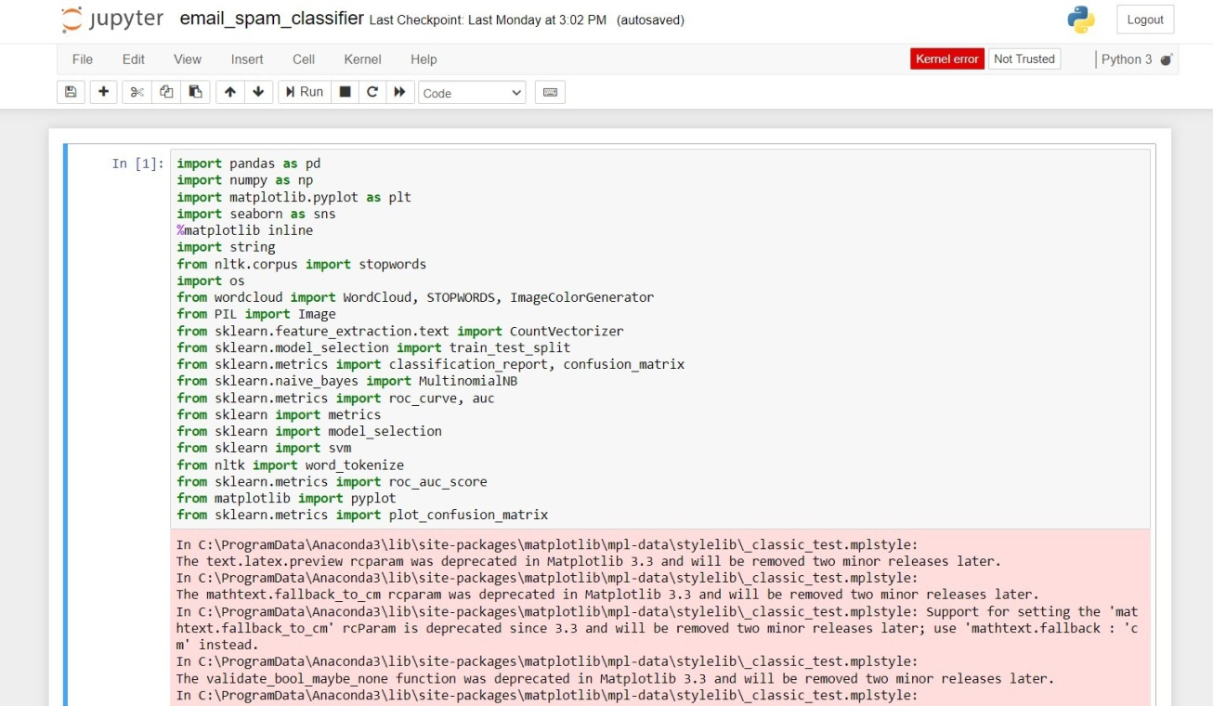

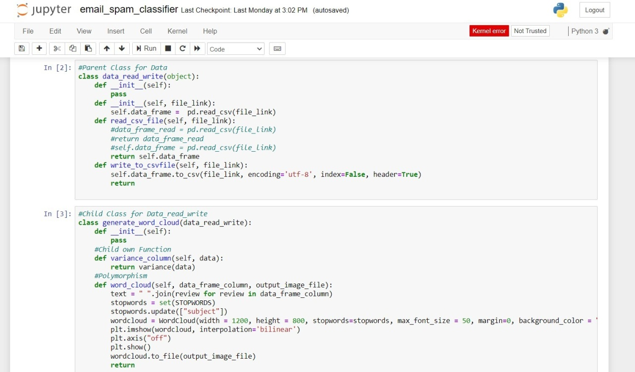

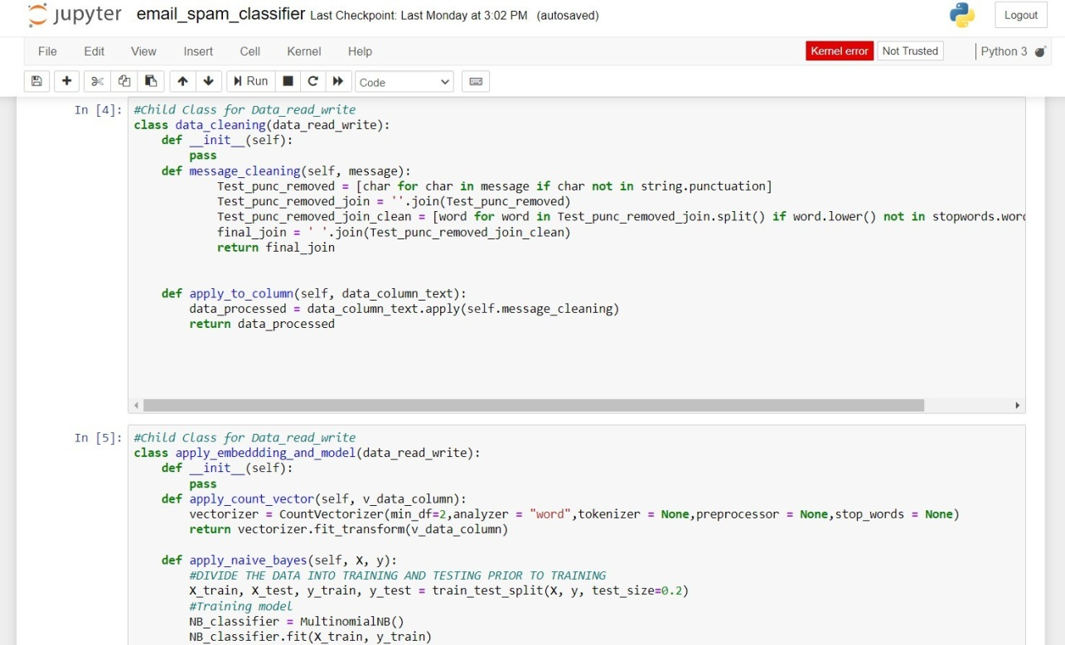

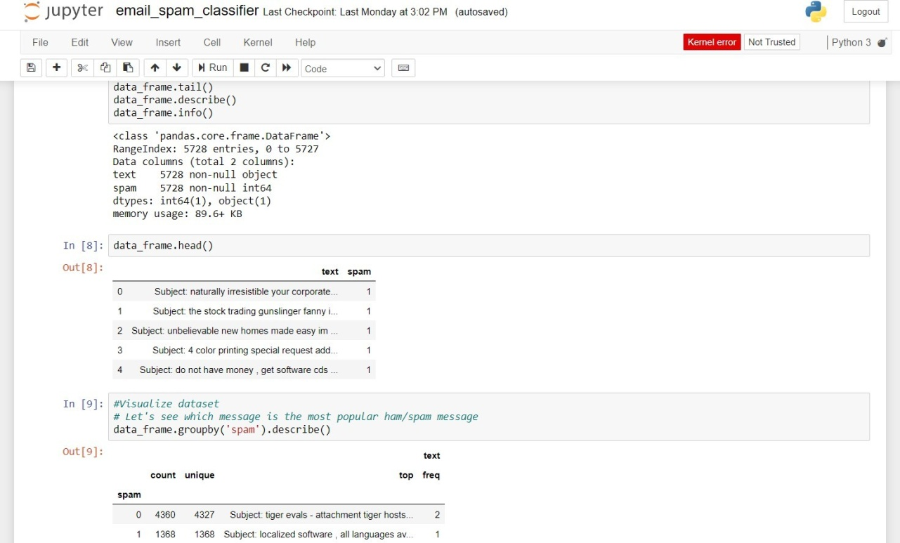

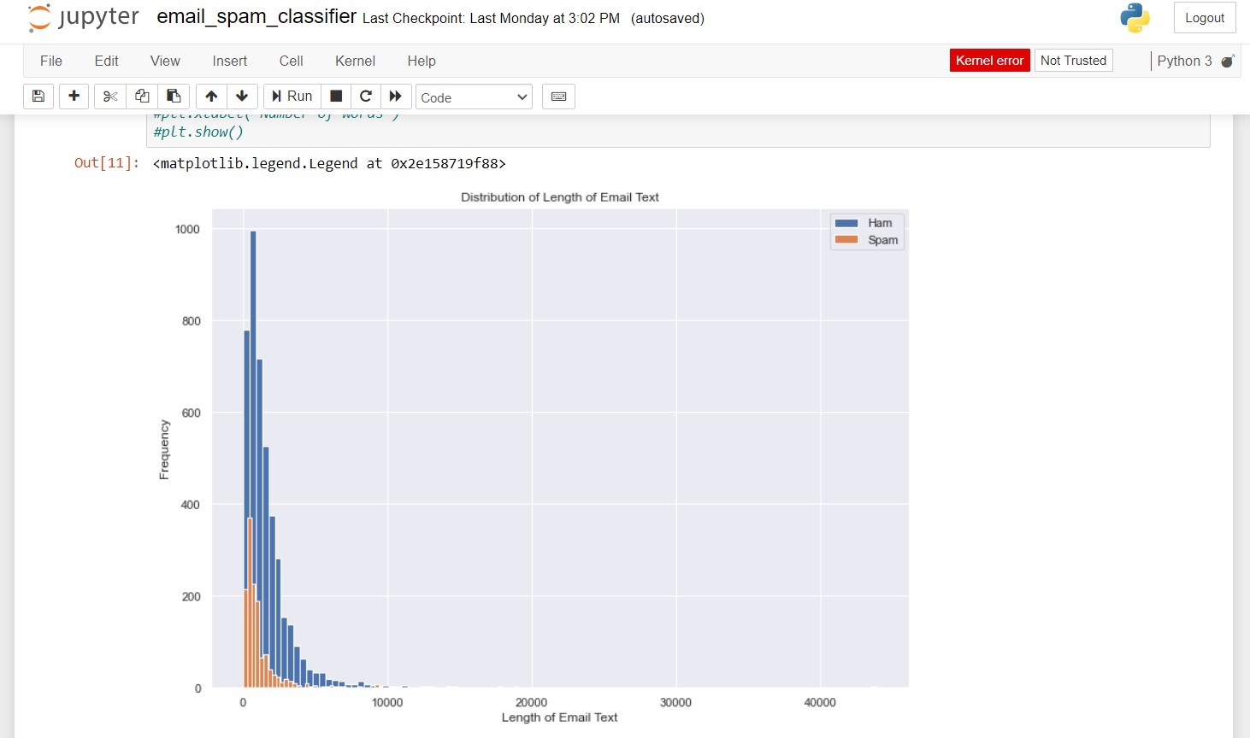

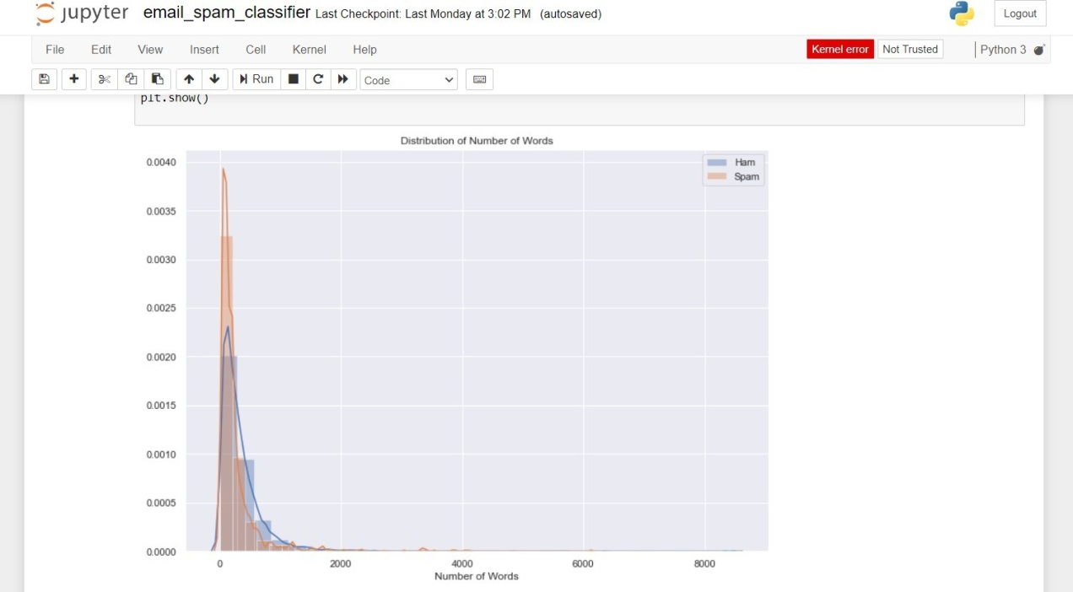

# CHAPTER 9 CONCLUSION

Inthisproject,weexploredtheapplicationofmachinelearningtechniques, specificallytheMultinomialNaiveBayesclassifier,foremailspamdetection.The goal was to develop a robust system capable of distinguishing between spam and legitimate emails based on their content.

Throughtheimplementationandevaluationoftheclassifieronadatasetofemail texts,weachievedacommendableaccuracyinclassifyingemailscorrectly.Theuse of TF-IDF transformation proved effective in capturing important features of the text, while the Naive Bayes classifier demonstrated reliable performance in distinguishing spam from legitimate emails.

Moving forward, enhancements could include exploring more advanced machine learningalgorithms,integratingmoresophisticatedfeatureengineeringtechniques, and incorporating real-time data streams for continuous learning and improvement ofthe classifier's accuracy and efficiency.

In conclusion, the project underscores the significance of machine learning incombatingemailspam,offeringapromisingapproachtoenhancingemailsecurity and user experience in digital communication platforms.

# REFERENCES

* Sahami, M., Dumais, S., Heckerman, D., & Horvitz, E. (1998). A Bayesianapproachtofilteringjunke-mail.InLearningforTextCategorization:Papers from the AAAI Workshop.
* Carreras,X.,&Marquez,L.(2001).Boostingtreesforanti-spamemailfiltering. In Proceedings of the Conference on Empirical Methods in Natural Language Processing (EMNLP).
* Drucker, H., Wu, D., & Vapnik, V. N. (1999). Support vector machines for spam categorization. IEEE Transactions on Neural Networks, 10(5), 1048-1054.
* Androutsopoulos, I., Koutsias, J., Chandrinos, K. V., & Paliouras, G. (2000). An evaluation of naive Bayesian anti-spam filtering. In Proceedings of the Workshopon Machine Learning in the New Information Age.
* Graham, P. (2002). A plan for spam. Retrieved from <http://www.paulgraham.com/spam.html>
* Duda, R. O., Hart, P. E., & Stork, D. G. (2000). Pattern Classification (2nd ed.). Wiley-Interscience.
* Bishop,C.M.(2006).PatternRecognitionandMachineLearning.Springer.
* Manning, C. D., Raghavan, P., & Schütze, H. (2008). Introduction to InformationRetrieval. Cambridge University Press.
* Scikit-learn:MachineLearninginPython.(n.d.).Retrievedfromhttps://scikit- learn.org/stable/
* TensorFlow: An Open Source Machine Learning Framework for Everyone. (n.d.). Retrieved from https://[www.tensorflow.org/](http://www.tensorflow.org/)
* Kaggle:YourMachineLearningandDataScienceCommunity.(n.d.).Retrieved from https://[www.kaggle.com/](http://www.kaggle.com/)
* GitHub: Where the world builds software. (n.d.). Retrieved from https://github.com/
* ApacheSpark:UnifiedAnalyticsEngineforBigData.(n.d.).Retrievedfromhttps://spark.apache.org/
* Chen,Z.,&Jackson,D.(2005).ABayesianapproachtofilteringjunke-mail using user feedback. Information Retrieval, 8(4), 439-455.
* Platt,J.C.(1999).Fasttrainingofsupportvectormachinesusingsequential minimal optimization. In Advances in Kernel Methods: Support Vector Learning.
* Zhang, X., &Zhang,G. (2007).A new hybrid model of support vector machines for spam classification. Computers & Operations Research, 34(10), 3091-3102.
* Kononenko, I., & Bratko, I. (1997). Information-based evaluation criterion for classifier's performance. In Proceedings of the 14th International Conference on Machine Learning.
* Mitchell,T.M.(1997).MachineLearning.McGraw-Hill.
* Domingos, P. (2012). A few useful things to know about machine learning. Communications of the ACM, 55(10), 78-87.
* Murphy,K.P.(2012).MachineLearning:AProbabilisticPerspective.MITPress.